Spark Streaming makes it easy to build scalable fault-tolerant streaming applications.

Reactive Streams is an initiative to provide a standard for asynchronous stream processing with non-blocking back pressure.

Kafka Streams is a client library for building applications and microservices, where the input and output data are stored in Kafka clusters.

Apache Spark
Apache Spark is a general framework for large-scale data processing that supports lots of different programming languages and concepts such as MapReduce, in-memory processing, stream processing, graph processing, and Machine Learning.
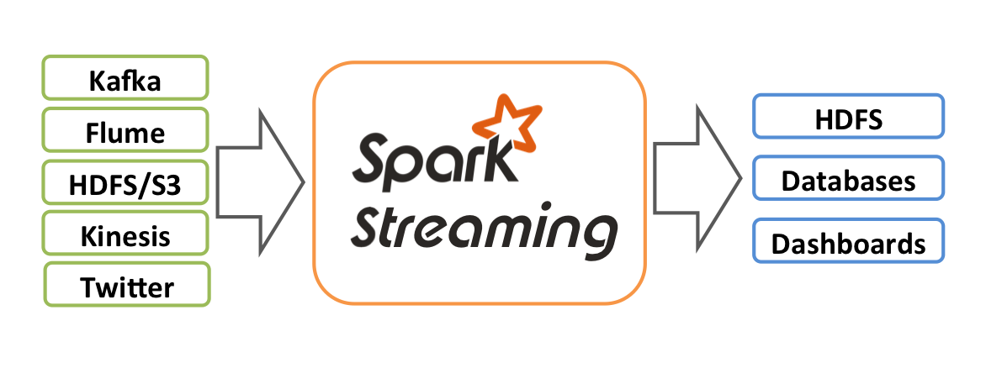

Spark Streaming receives live input data streams and divides the data into batches, which are then processed by the Spark engine to generate the final stream of results in batches.
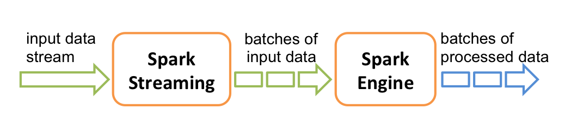

Spark Streaming provides a high-level abstraction called discretized stream or DStream, which represents a continuous stream of data. DStreams can be created either from input data streams from sources such as Kafka, Flume, and Kinesis, or by applying high-level operations on other DStreams.

Kafka Stream
Kafka Streams is a client library for processing and analyzing data stored in Kafka and either writes the resulting data back to Kafka or sends the final output to an external system.

Kafka Streams directly addresses a lot of the difficult problems in stream processing:
- Event-at-a-time processing (not microbatch) with millisecond latency.
- Stateful processing including distributed joins and aggregations.
- A convenient DSL.
- Windowing with out-of-order data using a DataFlow-like model.
- Distributed processing and fault-tolerance with fast failover.
- No-downtime rolling deployments.

Apache Spark can be used with Kafka to stream the data, but if you are deploying a Spark cluster for the sole purpose of this new application, that is definitely a big complexity hit.
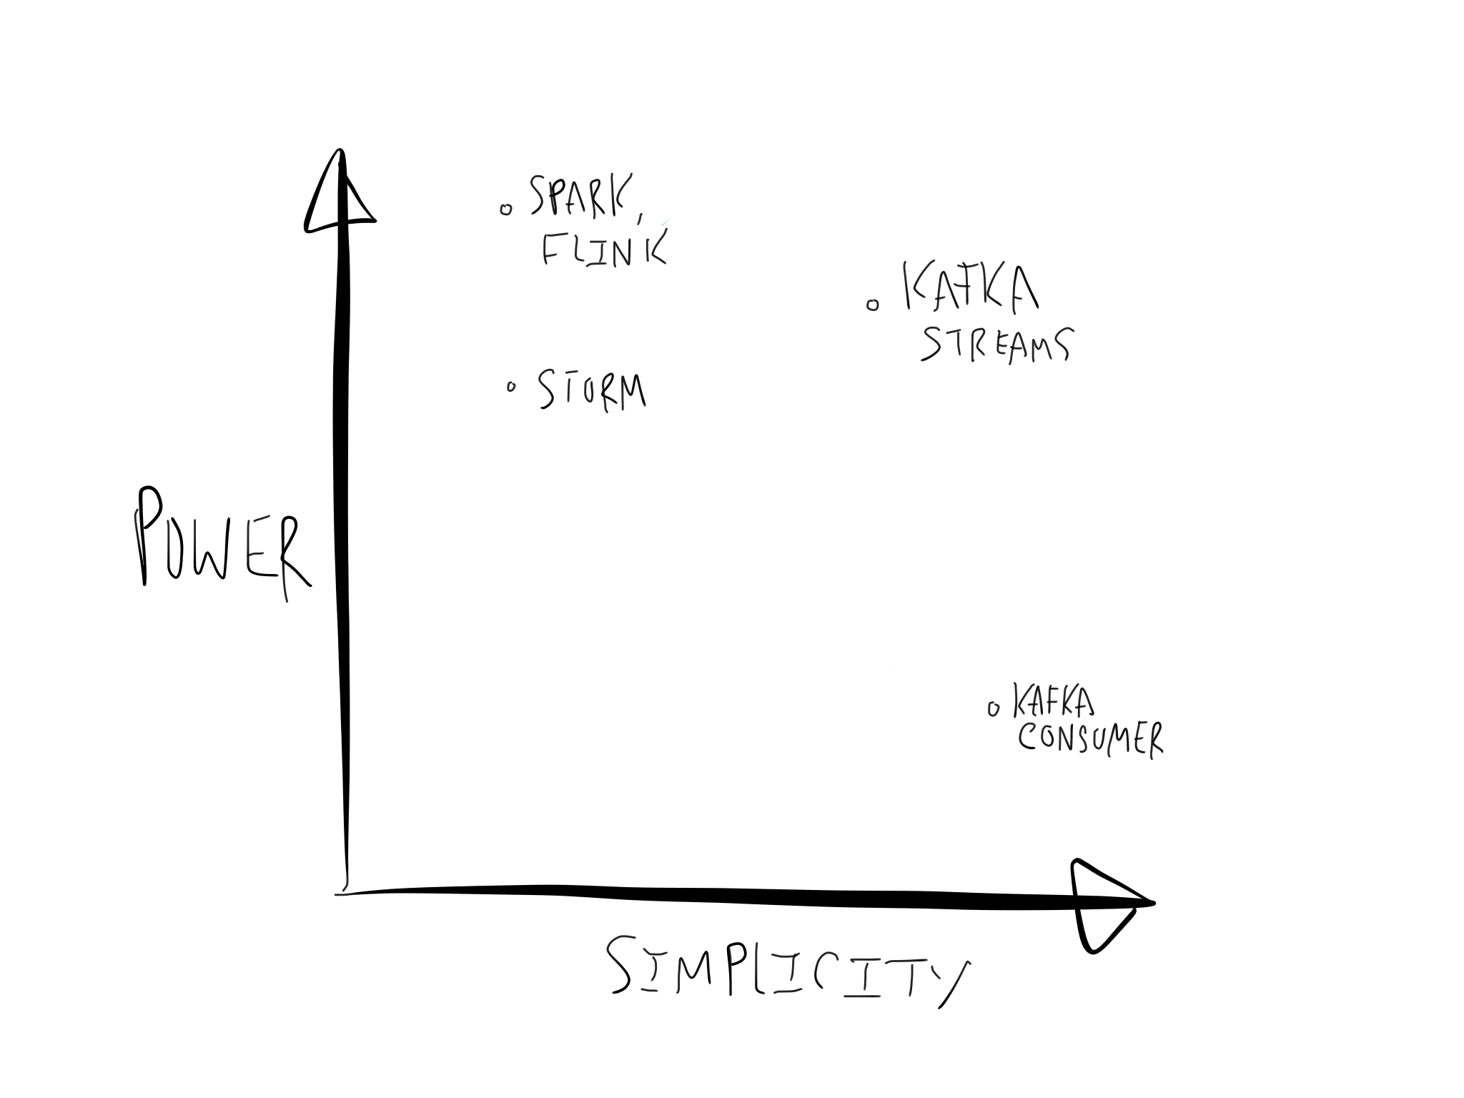

https://dzone.com/articles/spark-streaming-vs-kafka-stream-1

Reactive Streams
Reactive Streams is an initiative to provide a standard for asynchronous stream processing with non-blocking back pressure. This encompasses efforts aimed at runtime environments (JVM and JavaScript) as well as network protocols.
Reactive Streams is a specification. For Java programmers, Reactive Streams is an API. Reactive Streams gives us a common API for Reactive Programming in Java.
The Reactive Streams API is the product of a collaboration between engineers from Kaazing, Netflix, Pivotal, Red Hat, Twitter, Typesafe, and many others.
The main goal of Reactive Streams is to govern the exchange of stream data across an asynchronous boundary—think passing elements on to another thread or thread-pool—while ensuring that the receiving side is not forced to buffer arbitrary amounts of data. In other words, back pressure is an integral part of this model in order to allow the queues which mediate between threads to be bounded. The benefits of asynchronous processing would be negated if the communication of back pressure were synchronous, therefore care has to be taken to mandate fully non-blocking and asynchronous behavior of all aspects of a Reactive Streams implementation.

Reactive Manifesto Reactive Systems are:
- Responsive
- Resilient
- Elastic
- Message driven

https://dzone.com/articles/what-are-reactive-streams-in-java
http://www.reactive-streams.org/
https://www.reactivemanifesto.org/
https://databricks.com/session/reactive-streams-linking-reactive-application-to-spark-streaming

